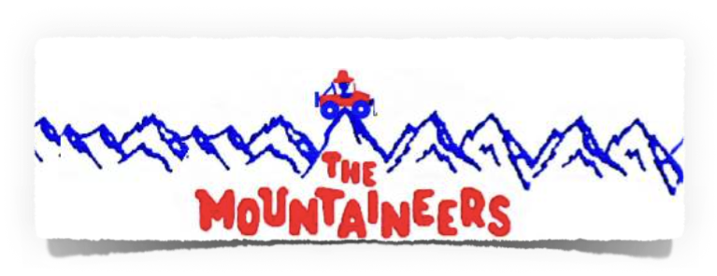
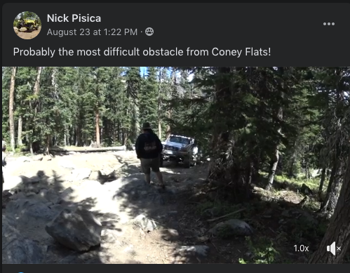
August Trip Report

September Club Trip
This month's trip is to Red Elephant Hill and Bill Moore Lake.
Please attend the meeting to find out about the trip and the meet up location.

www.mountaineers4x4.org

Check Out Trails on:
trailsofforad.com

MSV/CONEY FLATS
Be sure to check out the video Nick posted.

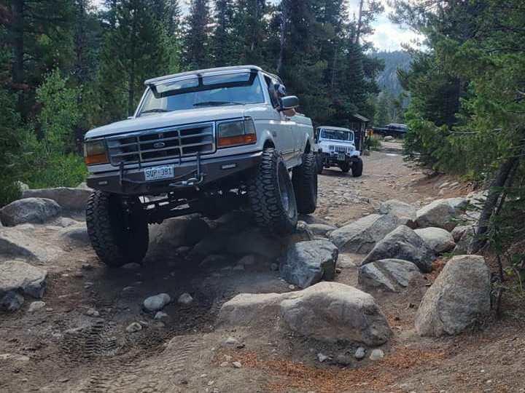
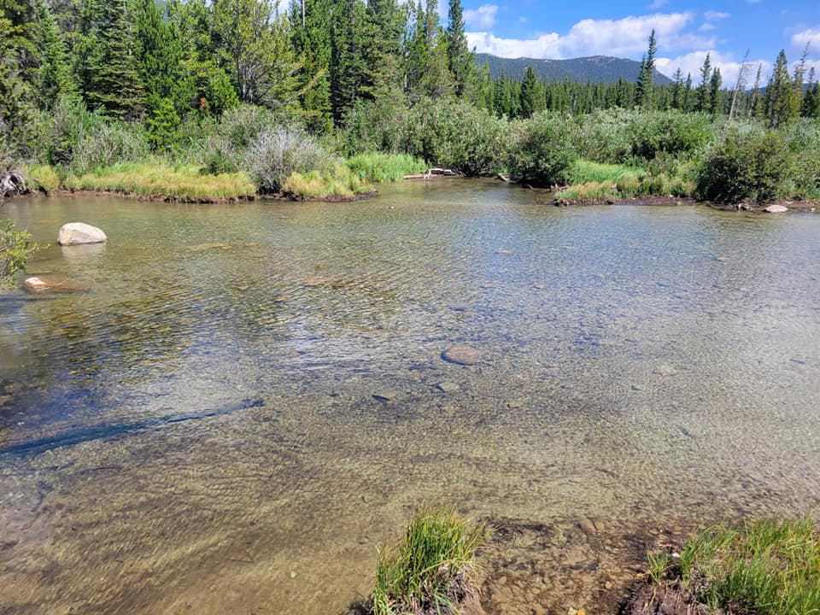
Thirteen rigs made the trip up to the Braskich’s property on Mount Ethel. Even though improvements have been made to the access road, especially at the turnoff from Stove Prairie Road, one must be very attentive navigating the route. It is a narrow shelf road with several switchbacks, a muddy section, and very steep in places. Once at the top the improvements that Mike and his neighbor Matt have made are very obvious. There is now ample parking for multiple vehicles, an observatory building, and a large rock and timber shelter.

Club Sponsors
Sessions Motorsports
1308 Riverside Ave Suite A
Fort Collins, CO 80524
970-493-6766
sessionsmotorsports.com

Addicted Offroad
328 S Link La #16
Fort Collins, CO 80524
307-363-2488
WWW.addictedoffroad.com

4 Wheel Parts
3686 Draft Horse Dr.
Loveland, CO 80538
970-203-0031
4wheelparts.com
Everyone took some time to check out the amenities and great views before sitting down and having lunch. Dave LeDeaux took the opportunity to try out some HAM communications at the peak of Mount Ethel and was able to make contact with someone in Nebraska. After everyone had a chance to eat lunch Mike brought out the golf ball cannon, several golf balls were shot into oblivion.
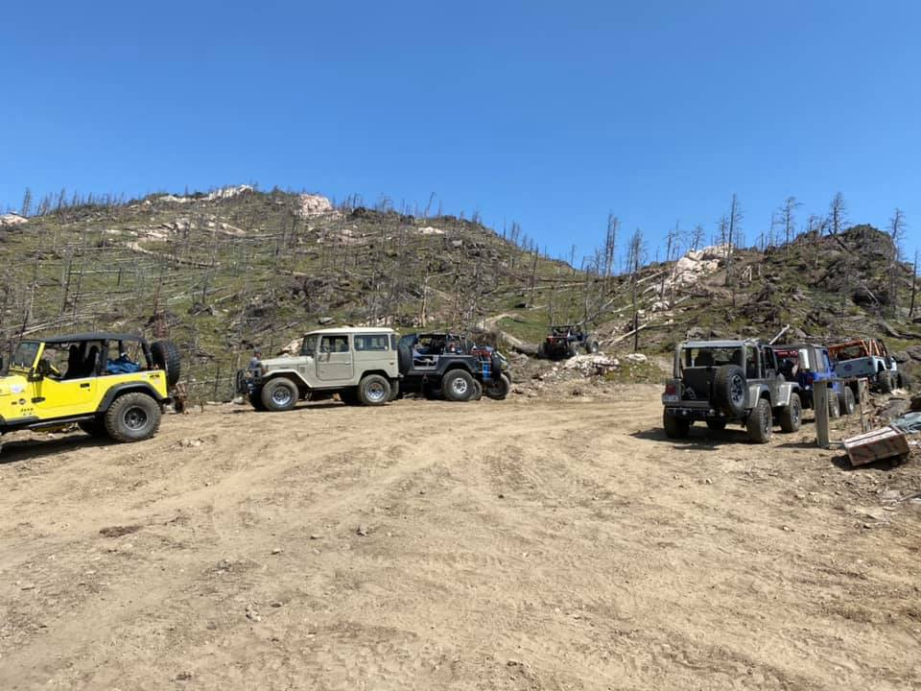
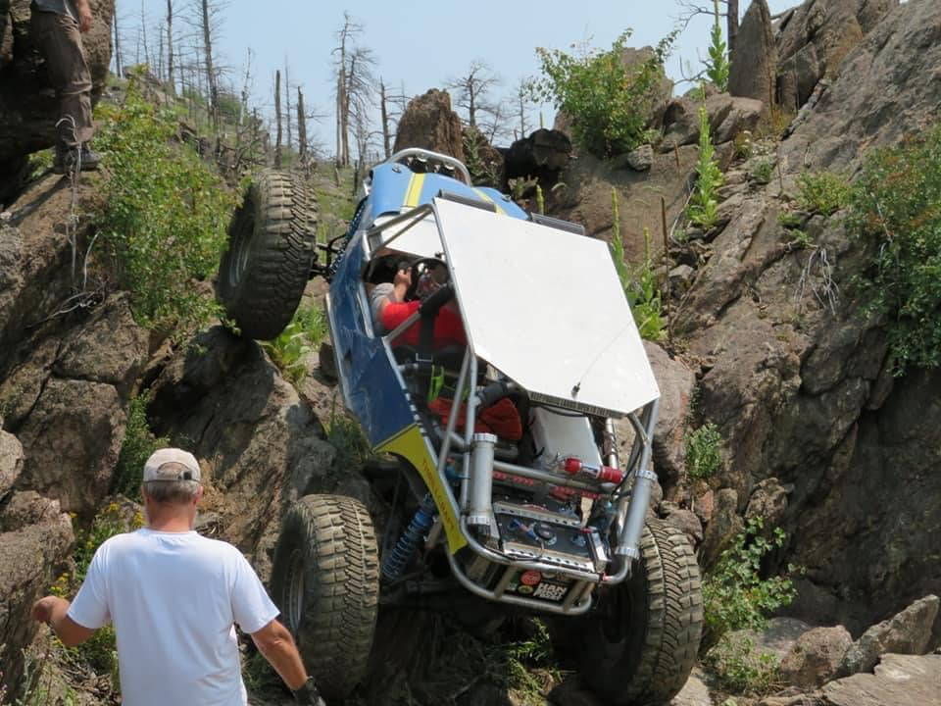
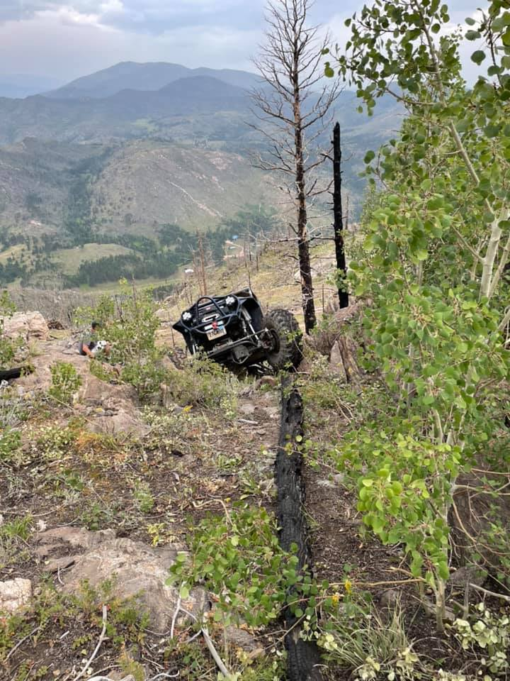
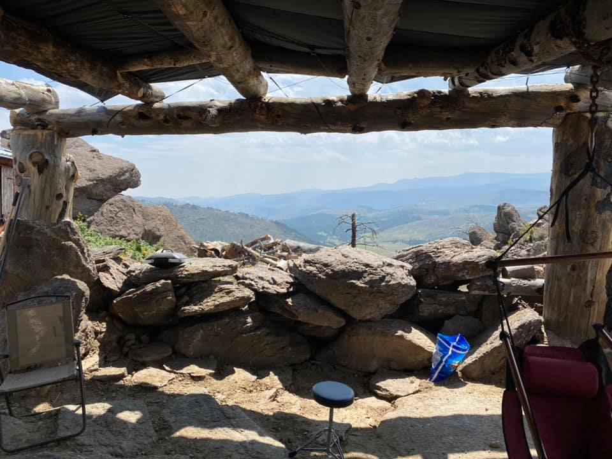

Club Sponsors
Bullhide Liner 4x4 & Auto Accessories
5817 South College Ave.
Ft. Collins CO
970-224-2288

Horsepower Auto Brokers, LLC
417 N. US HWY 287
Ft. Collins CO
970-482-2579
www.horsepowerauto.com

4X4 Off Road
1713 Willox Ct,
Ft. Collins
970-224-1133
www.4x4offroadnetwork.com

NAPA Auto Parts
316 S. Link Ln.
Ft. Collins
(970) 407-0020
A few members made a lap on the newly created loop road that goes through the property and near the summit. Later Mike Castell and Mike Braskich attempted a new climb over near the playground rock in their buggies, neither were able to make despite several valiant attempts. Mike B almost did but had to winch the last few feet, maybe next time. During this time most of the group had decided to leave as the sky was looking ominous. Shortly after Mike B winched up the climb the rain started. The remaining people took cover in the newly built shelter. The rain didn’t last long, and the sunny skies returned. After the rain Mike C tried some new lines to the east of the main cabin/shed. He was able to make two of them easily with some great spotting. He tried to make it across an area with large boulders but kept getting stuck on his belly pan and had to winch off it.
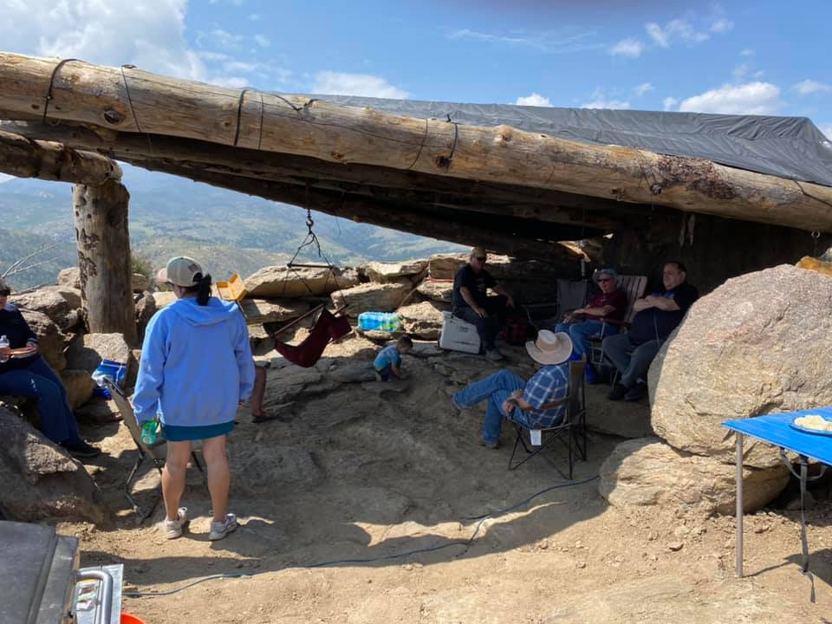
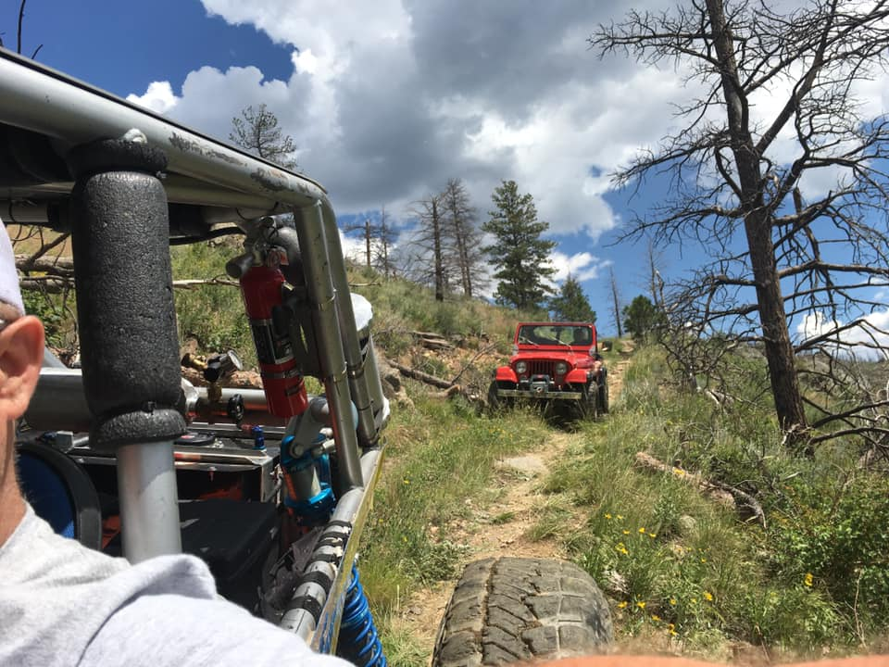
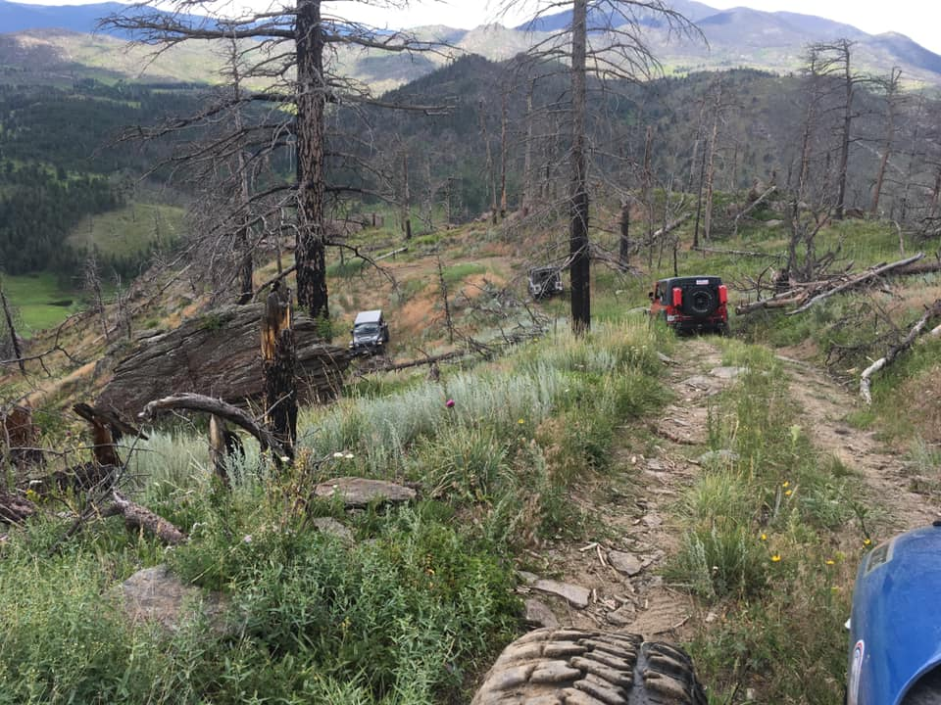
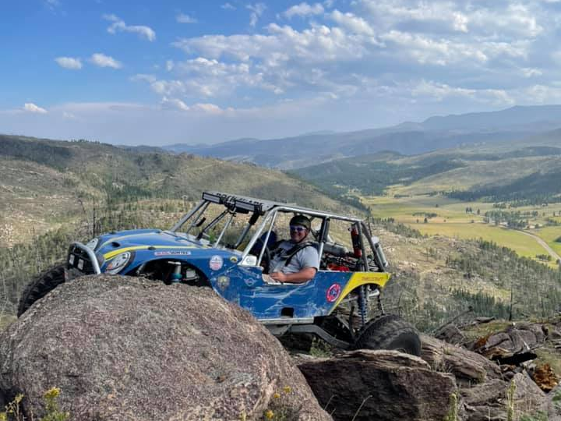
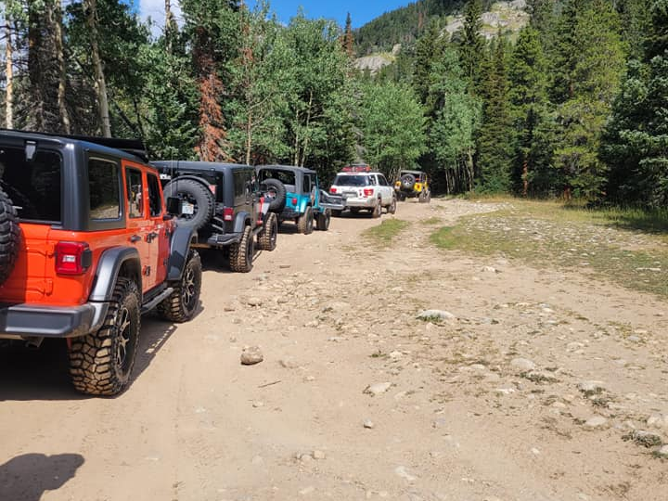
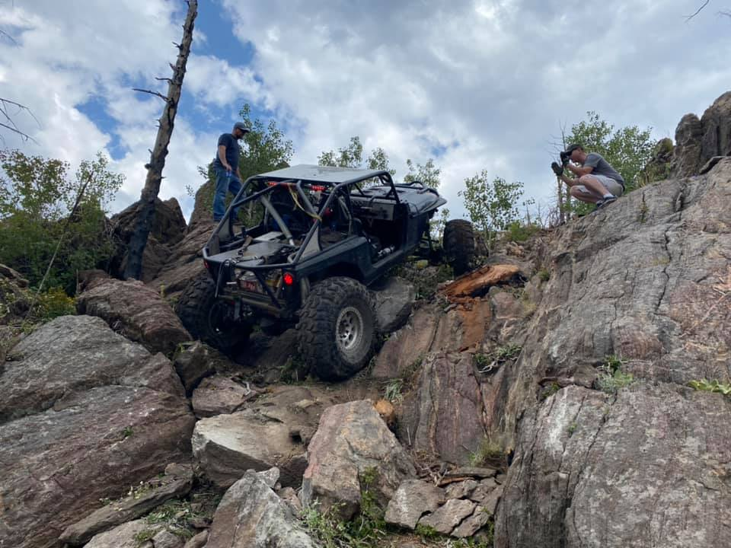

Club Sponsors
Always A Deal Inc.
Computer Services
Johnstown
970-310-7547
www.AlwaysaDeal.info

Maresh Cabling, LLC
7450 McCelland RD,
Wellington, CO 80549
970-556-7276
donmcabling@gmail.com

Wellington Toy Storage
4000 Washington Ave.
Wellington
970-498-2111
www.wellingtontoystorage.com

The Natural Path
2212 S. College Ave.
Ft. Collins CO
970-829-1110
thenaturalpathLtd.com
After that the remaining people packed everything up, secured all the buildings, and made their way down the access road. It was a great time and we are grateful that Mike and Bianca are willing to share their property with the club.

The Board will be holding the vote on the Bylaw and SOP changes at this meeting. Please plan to attend so you can make an informed vote.
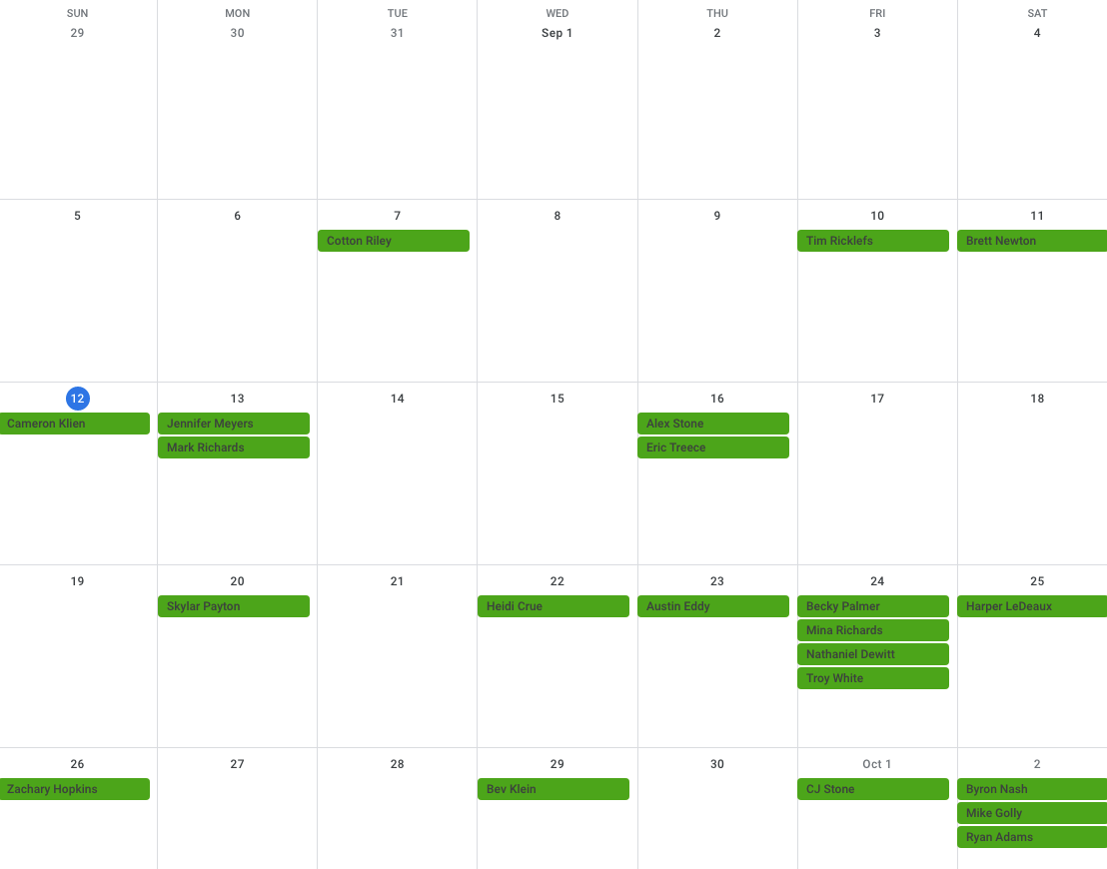

September 2021
We need your vote.
Type to enter text

